- Initialize the clock
- Set the language as you want:
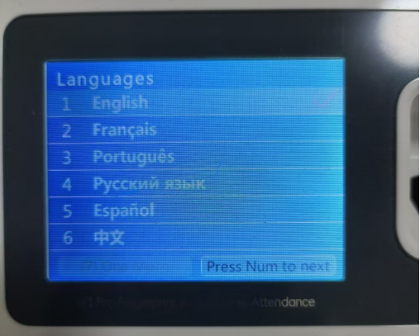
- Set the network as you have:
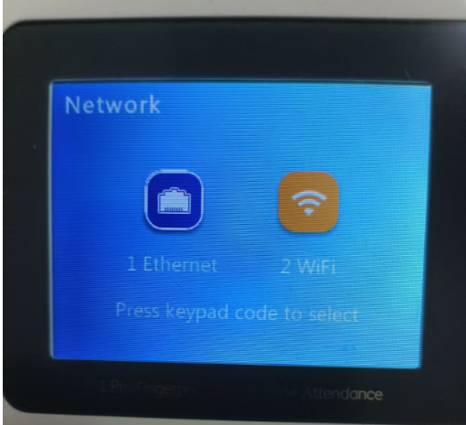
- Set your time zone:
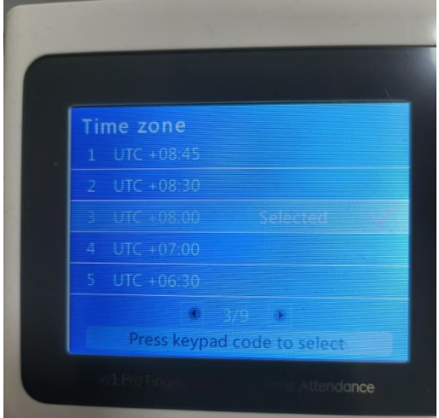
- Set your time:
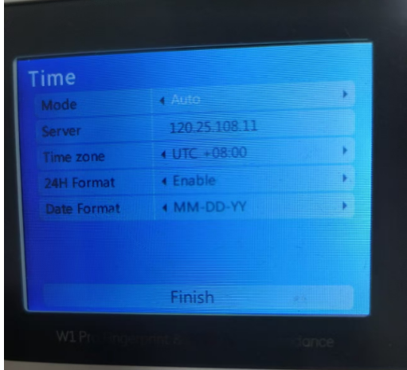
- Done:
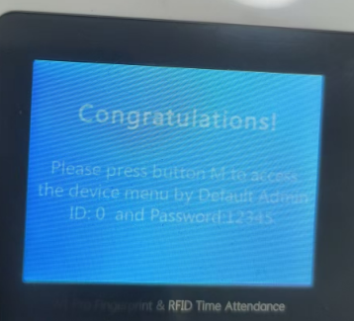
- How to get access to the clock settings
- Press 0 (the default ID)
- Press OK
- Press 12345 (the default password)
- Press OK
- How to set the communication password in the clock settings (Network/Comm Mode):
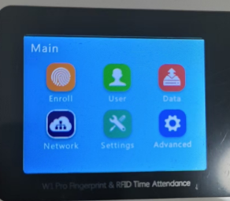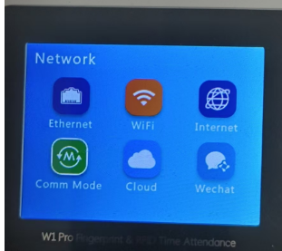
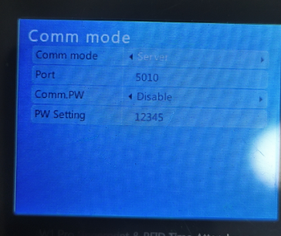
- Access to the web admin panel of the clock
- Assume the clock IP is 192.168.1.100, then type the following url in the browser to get access to the web admin panel of the clock:
http://192.168.1.100/
- Default credential is:
User Name: admin
Password: 12345
- How to set the communication password in the web admin panel:
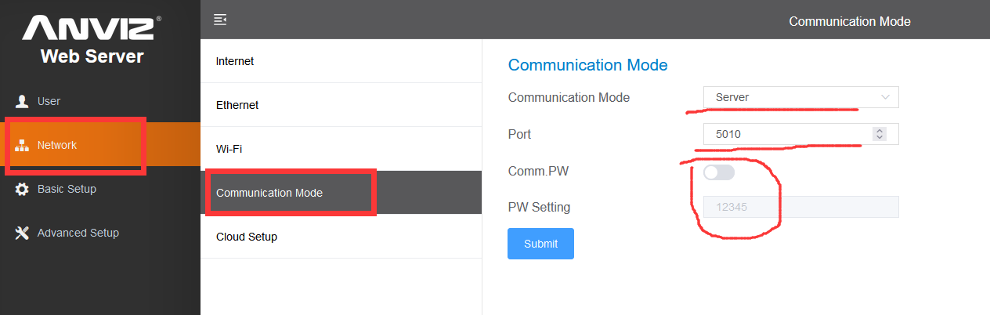
You could enable or disable the communication password.
- About the software
- Set the Service Port, Authentication Name and Authentication Password as you set in the clock settings or the web admin panel. If communication password is disabled, please set Authentication Name and Authentication Password as all empty.
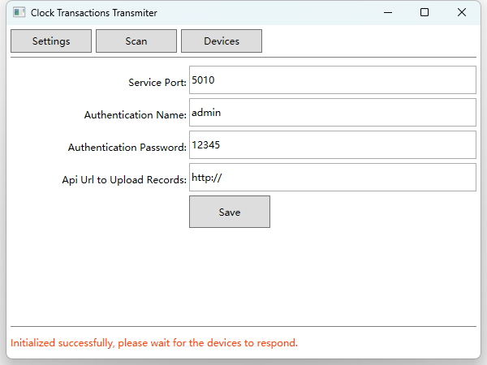
- Clicking “Scan” would rescan all the clocks in the same LAN.
- Clicking “Devices” would show all the found clocks in the same LAN.
- “Employees.csv” is located in the software directory, it stores all the employees information. It’s better to backup it regularly.
- “Records.csv” is located in the software directory, it stores all the records information. It’s better to backup it regularly.
- All the clocks in the same LAN should have the same service port and communication password.

